### Step 1: Prepare the Data Infrastructure

1. **Create the data lake and upload data**

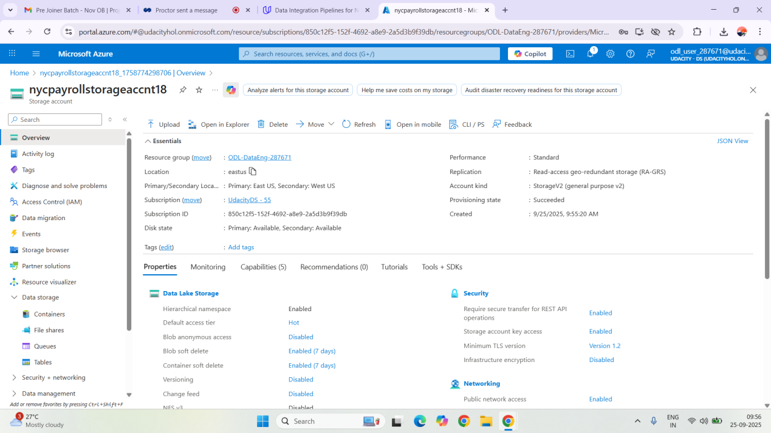

# Containers:Screenshot (58).png

**Directory:**

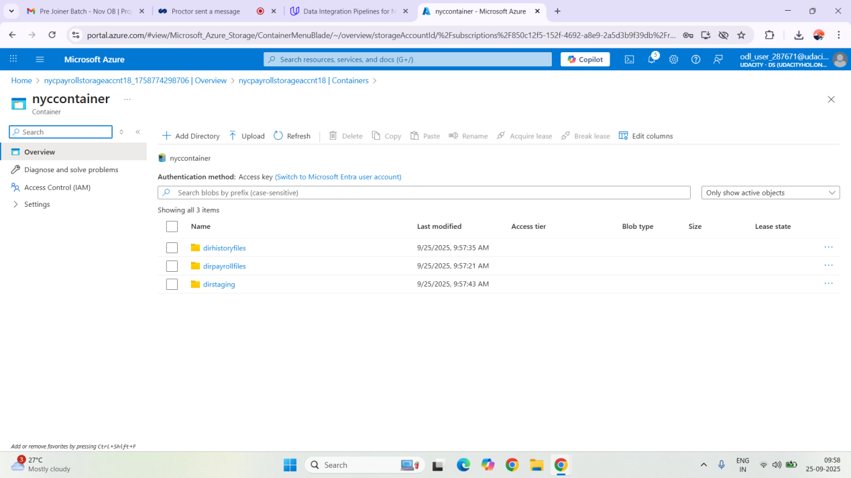

* **Dirpayrollfiles:**

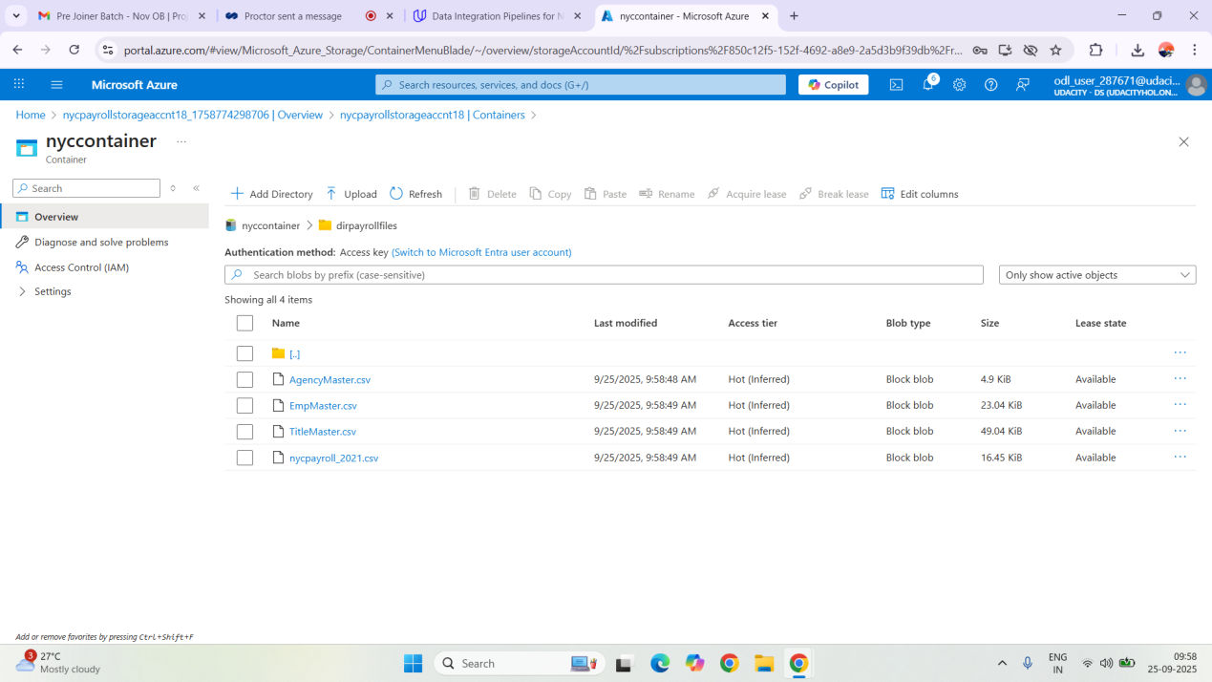

* **Dirhistoryfiles:**

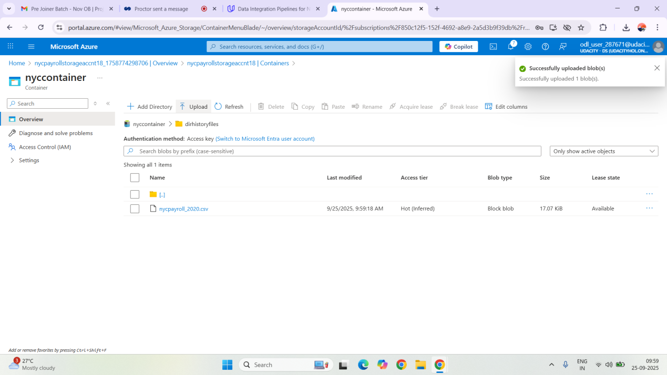

1. **Create an Azure Data Factory Resource**

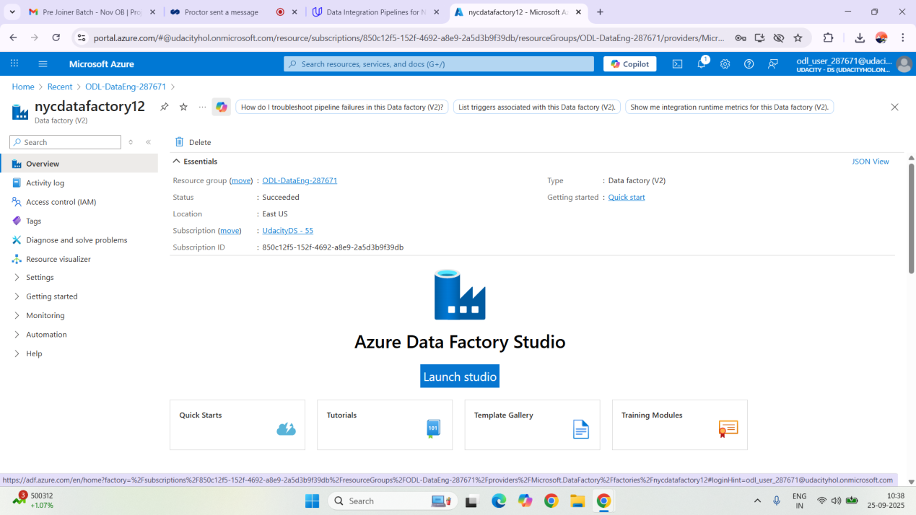

1. **Create a SQL Database**

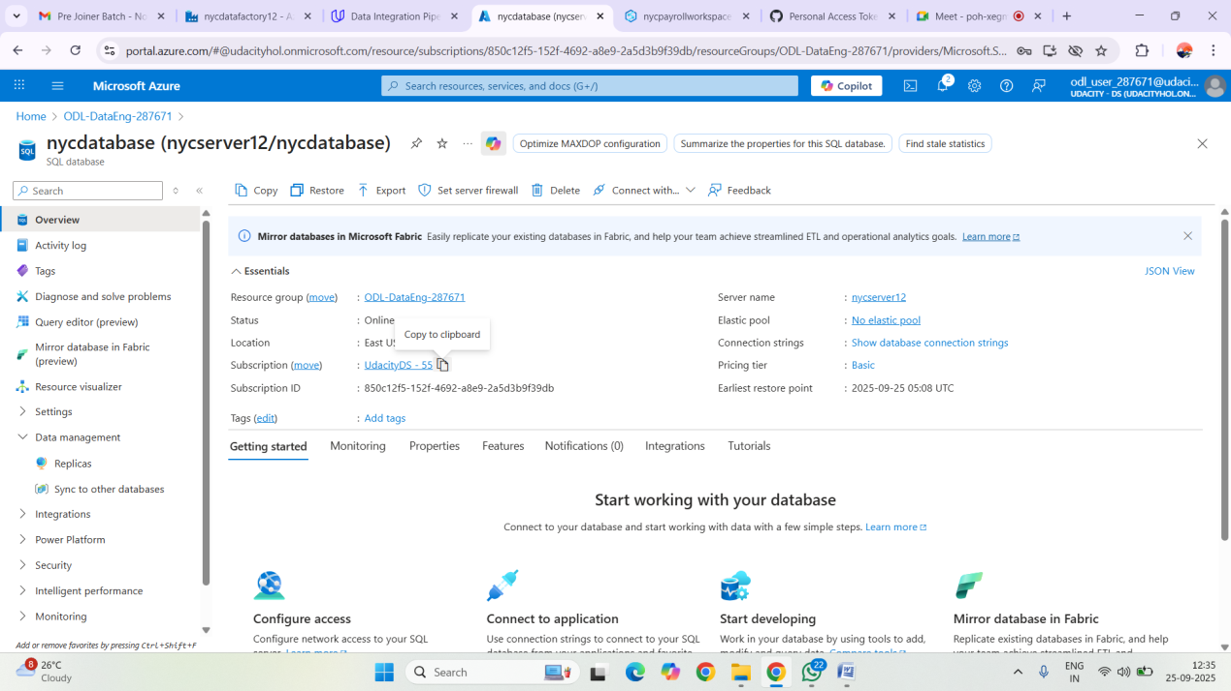

1. **Create a Synapse Analytics workspace**

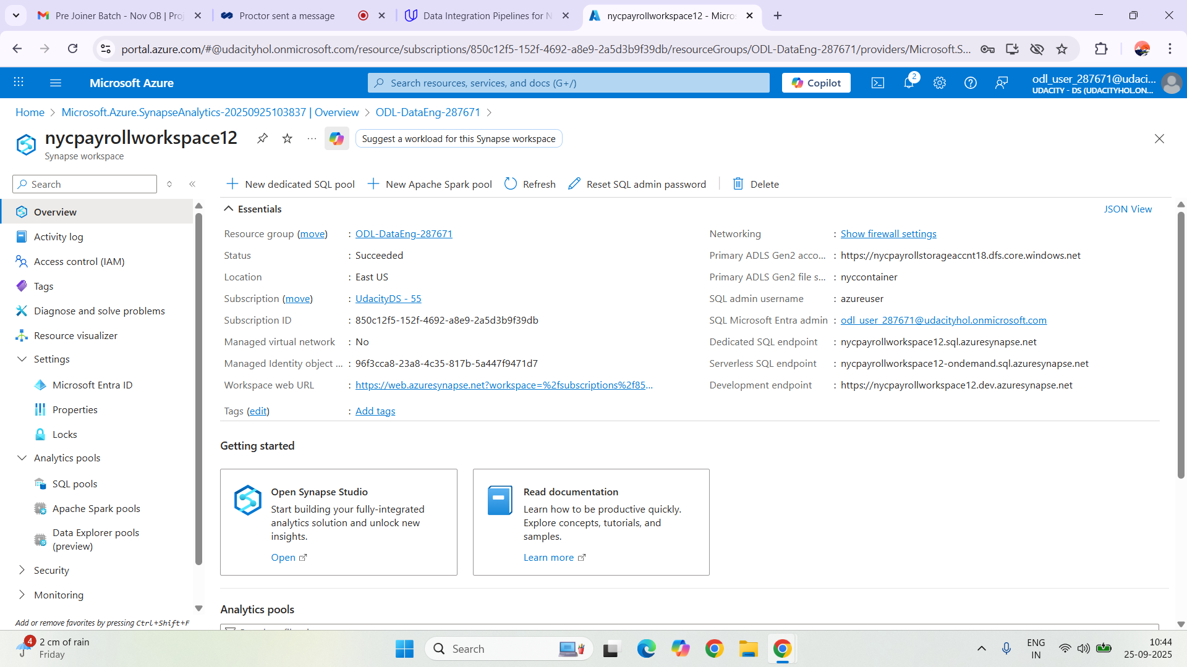

1. **Create summary data external table in Synapse Analytics workspace**

External table created in Synapse

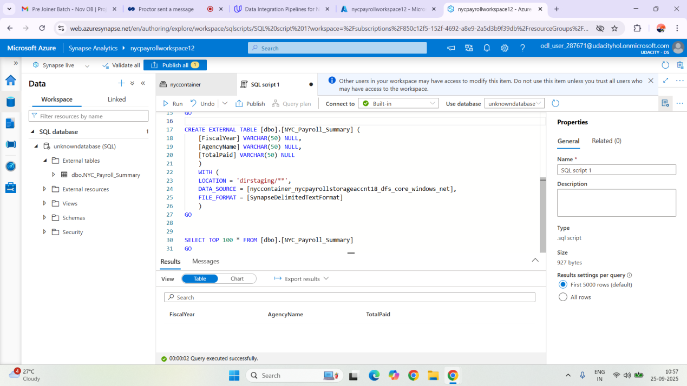

**6. Create master data tables and payroll transaction tables in SQL DB**

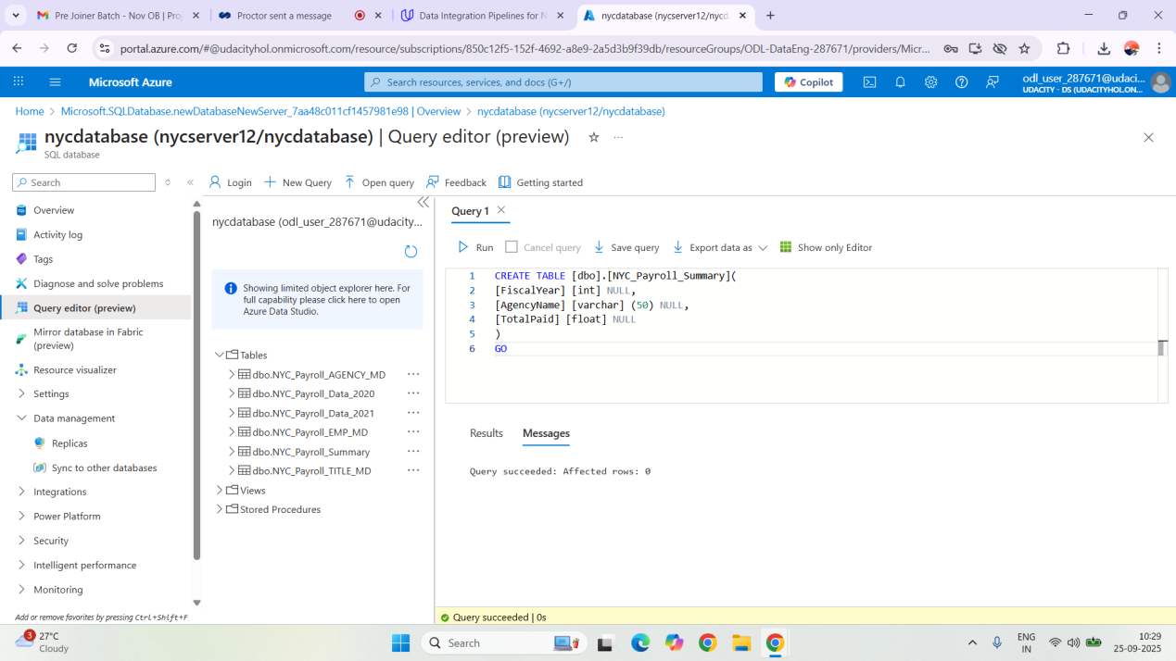

### Step 2: Create Linked Services

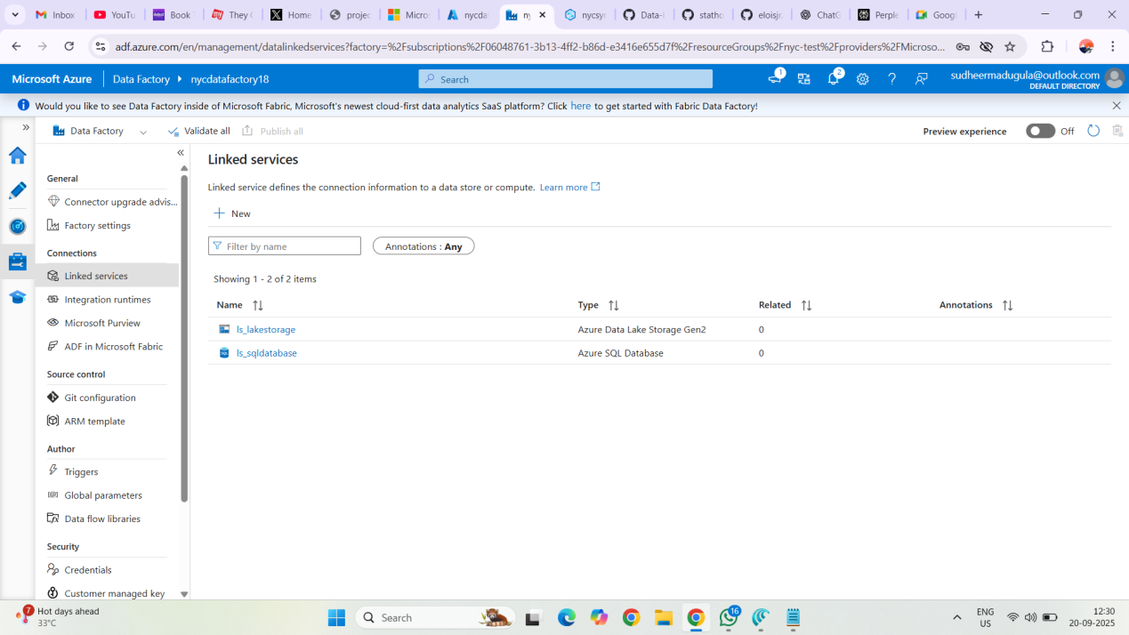

### Step 3: Create Datasets in Azure Data Factory

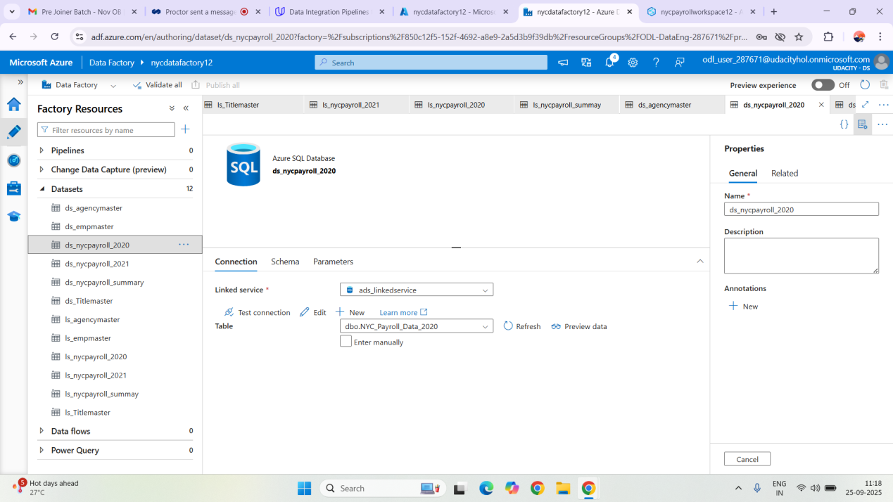

### 4: Create Data Flows

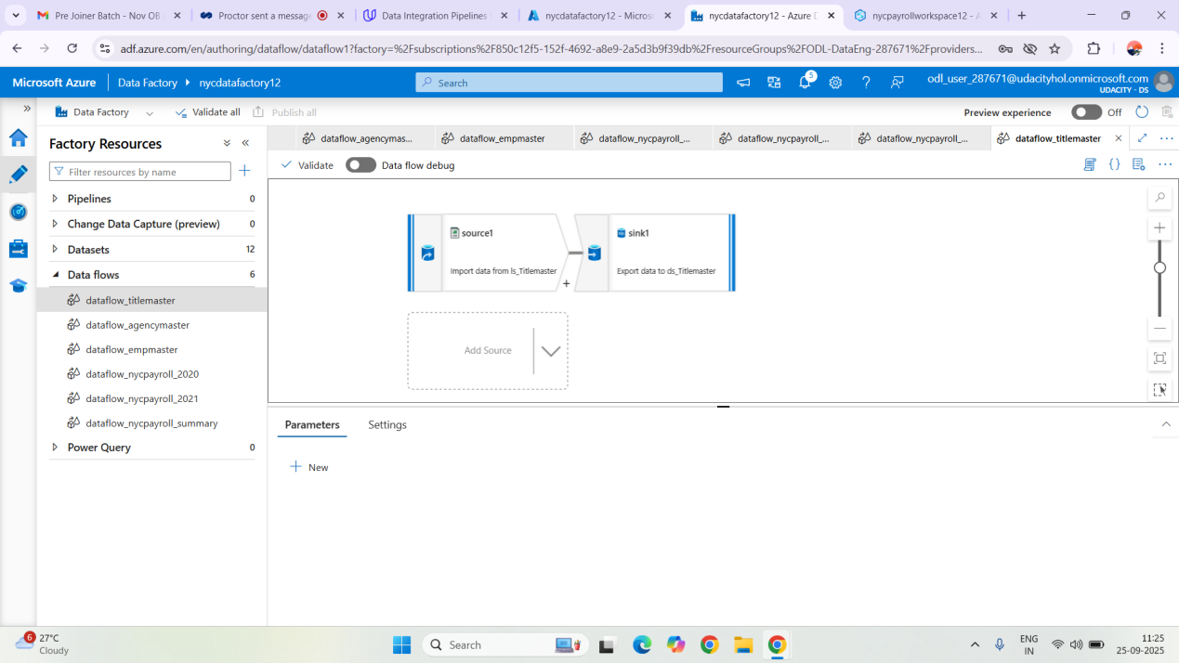

### Step 5: Data Aggregation and Parameterization

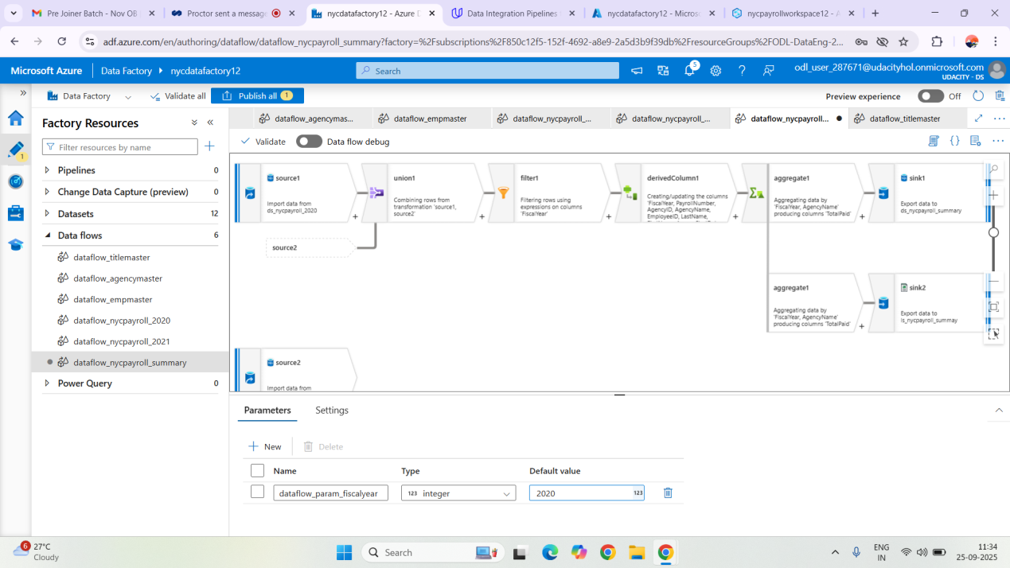

### Step 6: Pipeline Creation

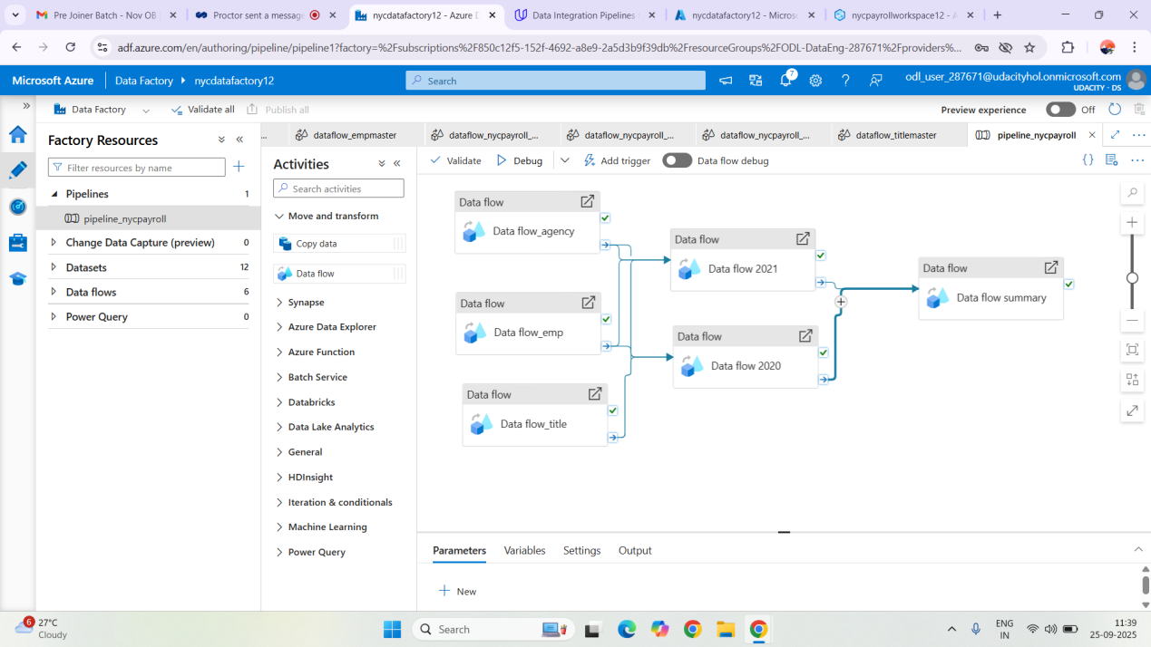

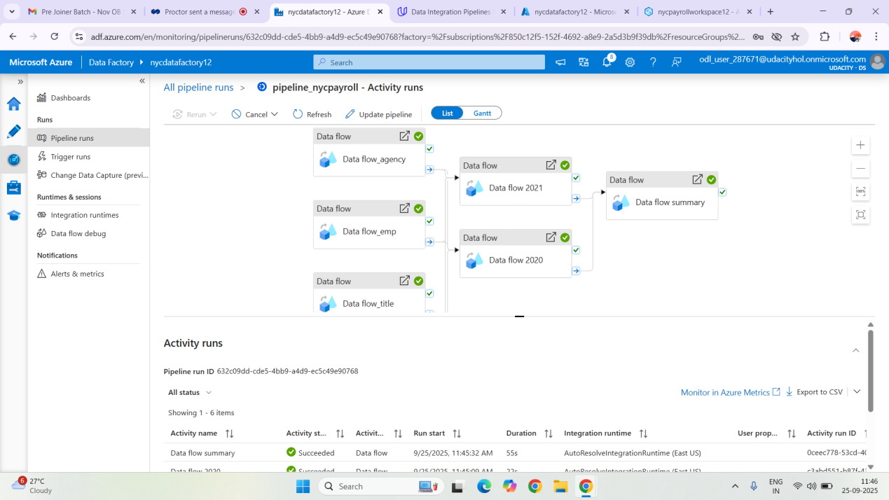

**Pipeline Running successfully without Errors:**

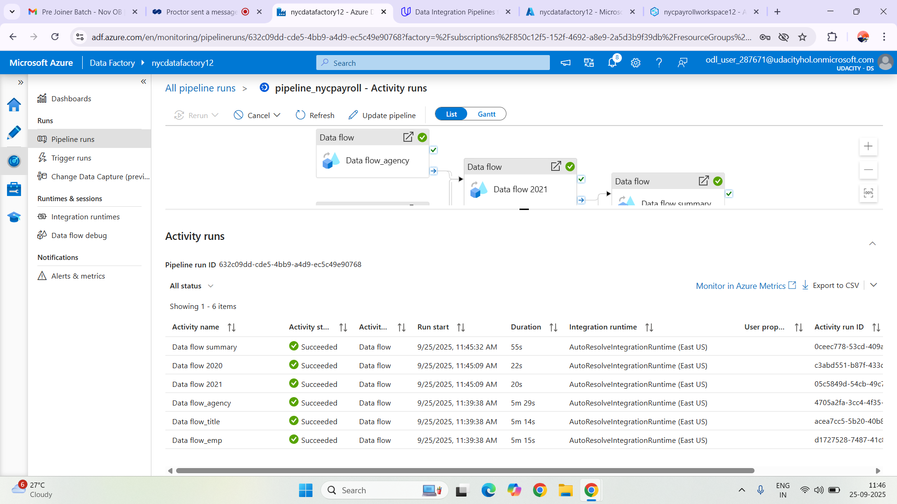

**Capture screenshot of query from SQL DB summary table**

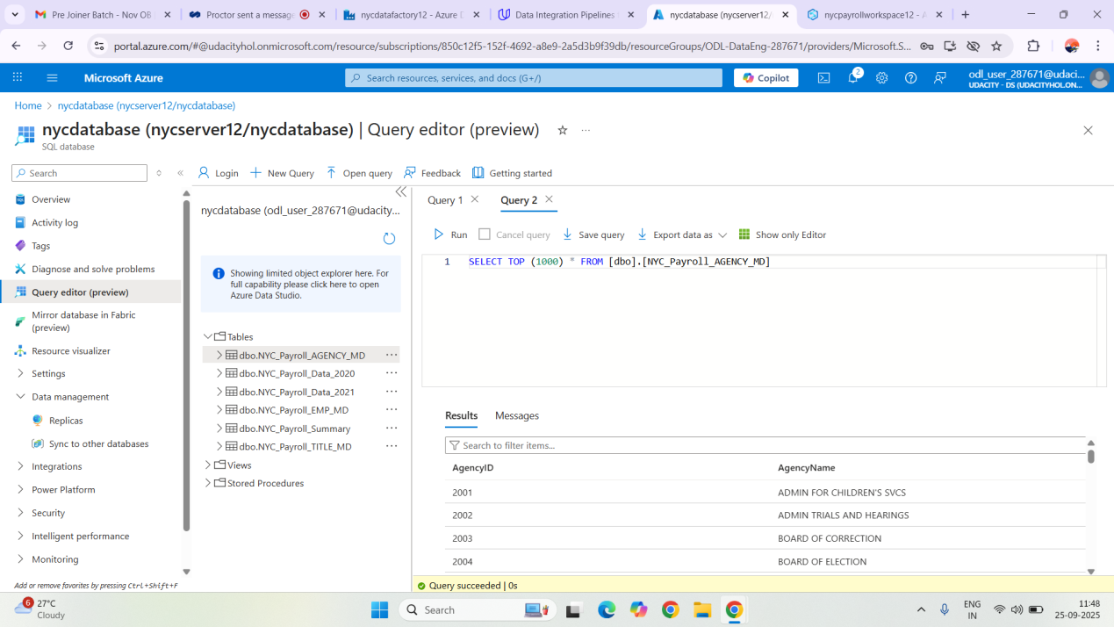

**dirstaging directory listing in Datalake**

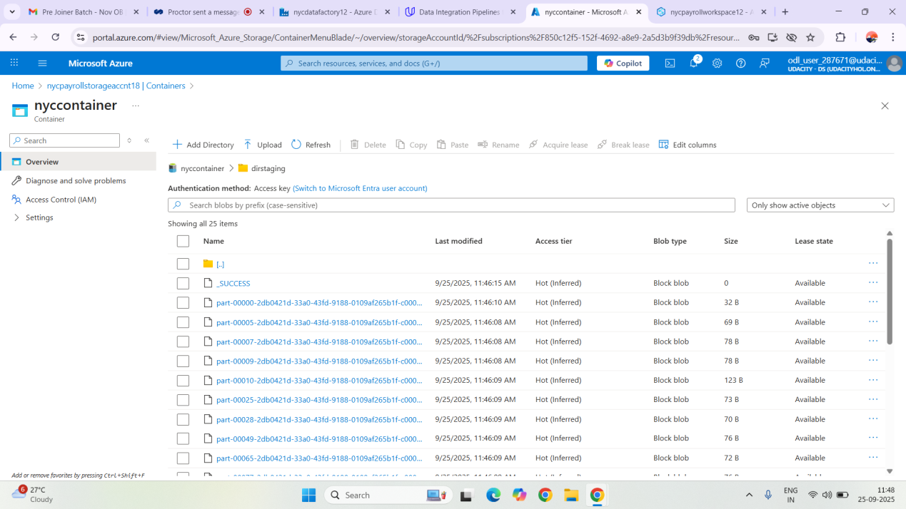

**Synapse Summary External Table:**

